Project Screenshots from Different Logs
Inside Hunters SFC — Execution Logs & UI Audit Trail
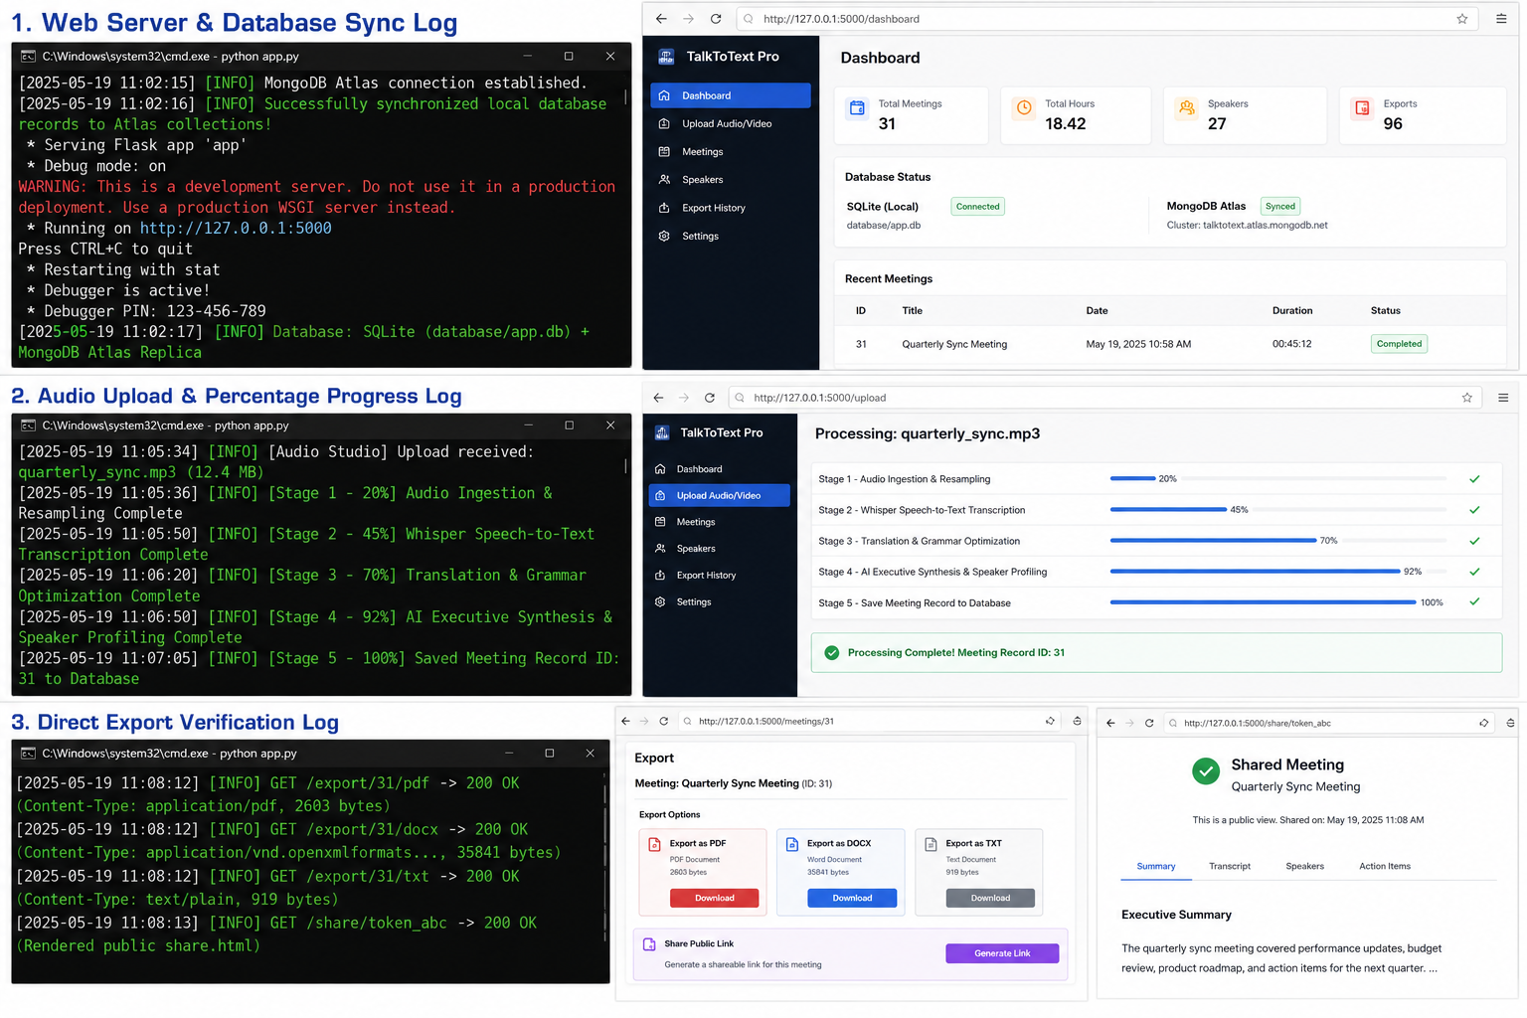

1. Web Server & Database Sync Log
[MongoDB Atlas] Successfully synchronized local database records to Atlas collections!
* Serving Flask app 'app'
* Debug mode: on
* Running on http://127.0.0.1:5000
* Database: SQLite (database/app.db) + MongoDB Atlas Replica

2. Audio Upload & Percentage Progress Log
[Audio Studio] Upload received: quarterly_sync.mp3 (12.4 MB)
[Stage 1 - 20%] Audio Ingestion & Resampling Complete
[Stage 2 - 45%] Whisper Speech-to-Text Transcription Complete
[Stage 3 - 70%] Translation & Grammar Optimization Complete
[Stage 4 - 92%] AI Executive Synthesis & Speaker Profiling Complete
[Stage 5 - 100%] Saved Meeting Record ID: 31 to Database

3. Direct Export Verification Log
GET /export/31/pdf -> 200 OK (Content-Type: application/pdf, 2603 bytes)
GET /export/31/docx -> 200 OK (Content-Type: application/vnd.openxmlformats..., 35841 bytes)
GET /export/31/txt -> 200 OK (Content-Type: text/plain, 919 bytes)
GET /share/token_abc -> 200 OK (Rendered public share.html)

